January 10, 2017

Dear Parents and Guardians,

The Student Senate is again sponsoring a special Commencement promotion for the sale of the Western New England University Afghan. Seventeen years ago the Student Senate launched this project in order to raise dollars for student scholarships. The project has been very successful and I hope you will consider supporting this scholarship fundraiser.

The afghan depicts buildings and “landmarks” that students associate with Western New England University, the student’s home for the last few years. Besides being a fabulous collegiate keepsake for your son or daughter, money raised from the sales continues to be used towards student scholarships. A special booklet has been prepared with the history of each building and landmark and is packed with each afghan.

Included with this letter is a small sketch of this beautiful keepsake, the afghan is a multi-colored design with fringed edges. If you would like to order today and return the form and payment, we will mail the afghan to your home. Please return your order form to us by May 1 so that we can mail it to you before Commencement, May 20. Checks may be payable to Western New England University.

Thank you for your time and I appreciate your consideration in helping to support the Student Senate Endowed Scholarship at Western New England University.

Respectfully yours,

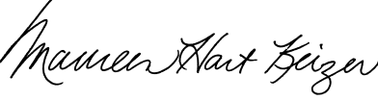
Maureen Hart Keizer
Associate Dean of Students/

Student Activities and Leadership
Development
Advisor, Student Senate

